DAPHNE TEST PROCEDURE

Jacques Ntahoturi, Miguel Marchan, Tom Deline

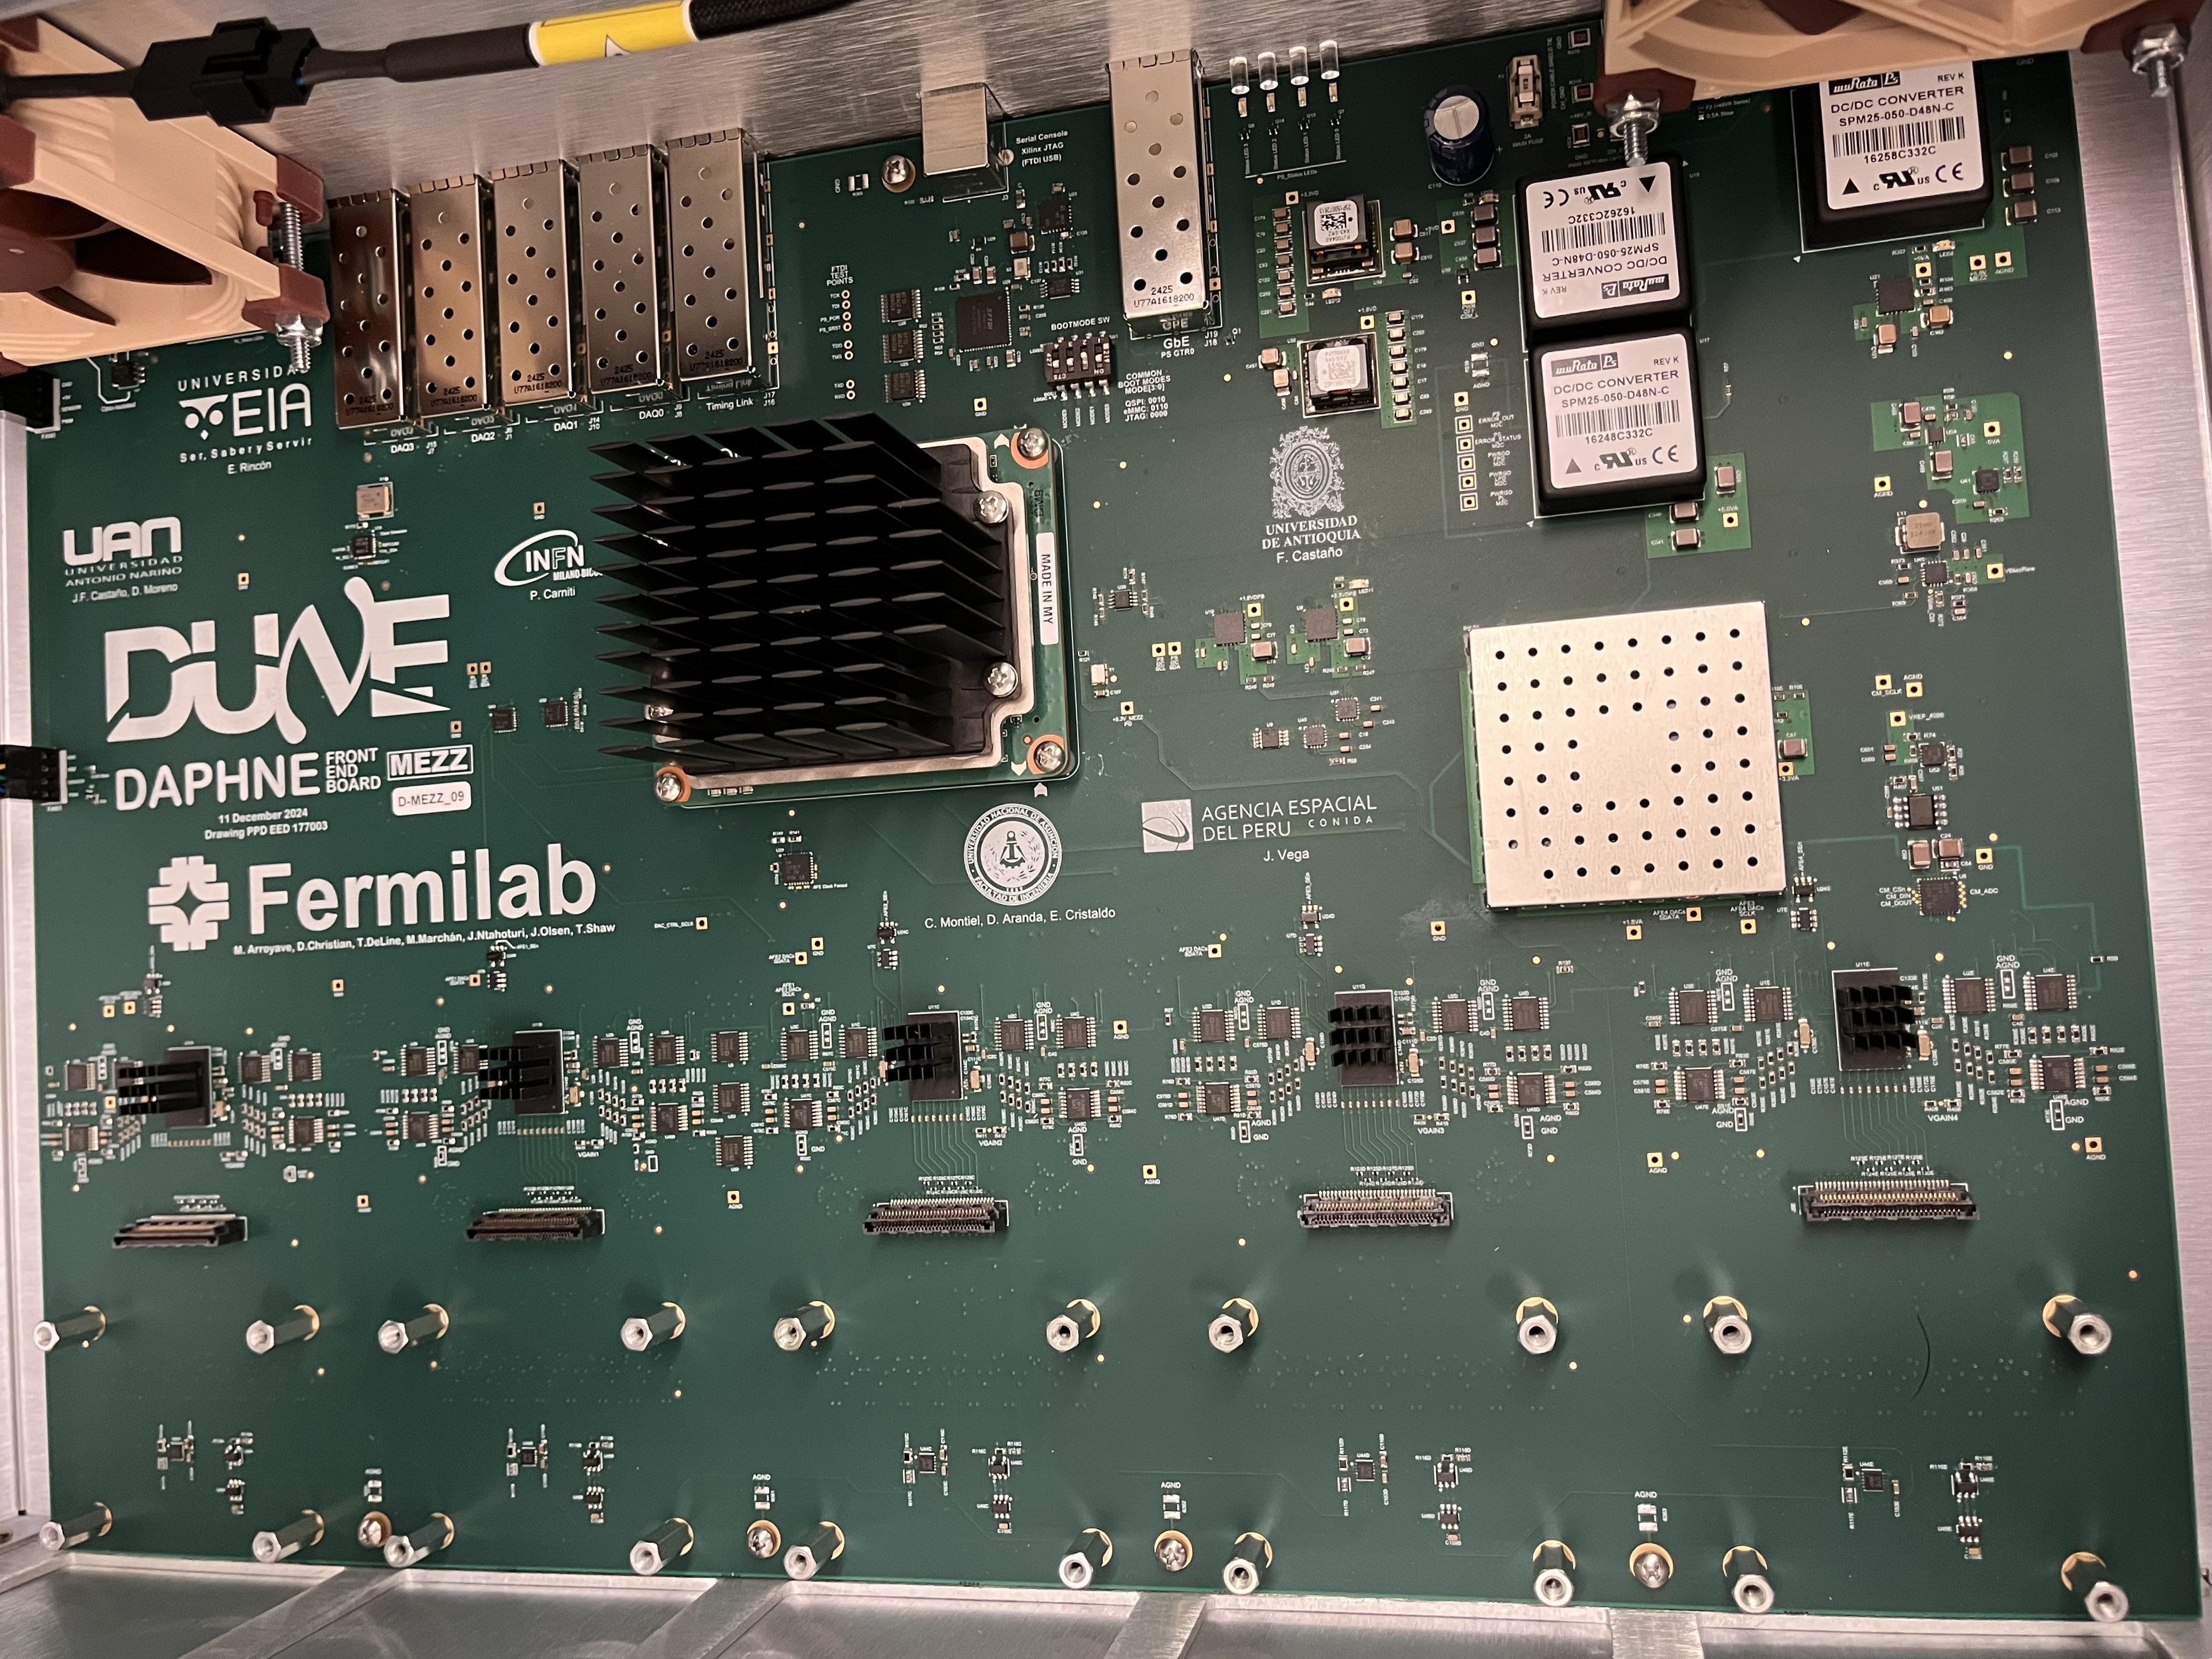

Table of Contents
Introduction 2
1. Purpose 2
2. Required Equipment 3
3. Test Sequence Overview 3
Appendix 9
Instructions for doing eye scans for the 10G links 9
Example of ffts on power rails 14
Example of FFT on open channels 14
Programing SoM and running qc/qa 15

Introduction
Document Title: Daphne Test Procedure
Document No.:
Revision: 1.1
Date: TBD
Prepared By: ___________________________
Reviewed By: ___________________________
Approved By: ___________________________

1. Purpose
To verify electrical, functional, and performance characteristics of the board from initial assembly through full system integration. This procedure ensures all power, signal, and comunication subsystems operate within specification

2. Required Equipment
- Bench power supplies (0–48 V, up to 2 A)

- Multimeter

- Oscilloscope (at least 200 MHz bandwidth)

- USB type C cable interface and PC

- Thermal camera

- Putty/tera term installed on host PC
- 10G capable loopback SFPs

3. Test Sequence Overview
Upon arrival of the board, before unpacking the board; make sure to the testing environment is proper and ESD wraps are available and follow the following instructions:

Verification criteria | Criteria description | Verified by (initials) | Date | Pass/Fail
 | Setup Testing environment
Clean work area | Work area should be free of anything that could cause shorts on the board
Check for safety equipment | Make sure ESD wrap and mat are available and property grounded
Unpack board | Put on ESD wrap and unpack the board for visual inspection and testing
 | Visual Inspection
component placement | Verify correct component placement, polarity (electrolytic caps, diodes, LEDs)
Through hole components | Confirm shielding and connectors are seated (SFP, DSUB, etc).
Dimensional accuracy | Board outline, hole locations, slots, and cutouts within specified tolerances
Plating and surface finish | Copper plating, via integrity, and surface finish
Solder mask and silkscreen | Color, registration, and clarity meet visual inspection standards; no encroachment on pads
Visual inspection | Boards free of scratches, delamination, warpage, or contamination
 | Electrical Test
Shorts and opens test | No shorted or open nets; all continuity verified on all power rails
Power supply set up | Set the power supply at 48V 0.5A
Smoke / visual inspection test | Turn on the power supply for 2 sec and turn it off. There should be no visible damage, smoke, or overheating upon power-up
Power-on test | All rails start in correct order and stabilize within design voltage limits. LEDs should come one.
Power-rail voltage and ripple test | Voltage levels and ripple within specified tolerance; no instability under load (ripples should be within 10mv)
VIN | Measure 48V 0.5A main input power. Level and FFT to see noise
+5.5VA | Measure DC/DC power rail Level and FFT noise
+5VD | Measure DC/DC power rail Level and FFT noise
+5.5V_MEZ | Measure +5.5V power rail Level and FFT noise
-5.5V_MEZ | Measure -5.5V power rail Level and FFT noise
+3.3VA | Measure +3.3V power rail Level and FFT noise
+3.3VD | Measure +3.3V power rail Level and FFT noise
+3.3VDPS (need som) | Measure +3.3V power rail Level and FFT noise
1.8VD | Measure 1.8V power rail Level and FFT noise
1.8VDPS (need som) | Measure 1.8V power rail Level and FFT noise
1.8VA | Measure 1.8V power rail Level and FFT noise
+4.096VREF | Measure +4.096V power rail Level and FFT noise
-5VA | Measure -5V power rail Level and FFT noise
+5VA | Measure +5V power rail Level and FFT noise
+VBIAS_RAW | Measure Vbias raw power rail Level and FFT noise
Inrush and current draw test | Inrush and steady-state current within limits; no over-current protection trips
 | Functionality Test
Program KRIA SOM | Follow instructions bellow to program the SOM.
KRIA SOM | Mount programed KRIA SOM carefully and check alignment.
USB interface | Connect USB cable to the host computer and see if the computer’s device manager detects it.
Establish serial connection | Open tera term or putty and establish a serial connection  Command: screen /dev/ttyUSB1 115200
BOOT modes | Change the board into QSPI boot mode and turn on the board and observe the boot process.
Petalux OS boot and runtime | OS boots correctly, and stable
FPGA configuration and CRC check | Bitstream is programed into the FPGA configuration successful
Remote FPGA reprogramming | Verified remote reprograming of the FPGA bitstream through ssh
I2C interface | Run “i2cdetect” command and confirm that there is at least 2 i2c buses detected. And verified device addresses
Temp sensor | Run temperature sensor script and confirm that the temperature sensor returns sensible data
Clock generator | Program the clock generator using provided script and with scope, verify that the clock is correct
Clock fanout | With a scope verify that the clock fanout is outputting 62.5MHz clock to all AFEs
SPI interface | With a scope, probe the spi clock to make sure it gets toggled
DAC Test | Run the DAC programming script and measure the output voltage to confirm that it is what is expected
ADC Test | Run the script to test the ADC and confirm the readback
AFE Test | Run the script to program the AFEs and confirm the programing with the readbacks
AFE data | Run the script to acquire afe data and confirm that the data is proper
External Triger | Run the script to acquire data and use external trigger signal to trigger the data and confirm that the trigger functions properly
FANs | Change the fan speed and confirm the change.
1G Ethernet interface test | Link-up the ethernet and confirm you can ping other systems on the network and other systems on the network can ping DAPHNE
High-speed Ethernet | 10 GbE test | Bit Error Rate (BER) ≤ 1×10⁻¹²; stable link and eye-diagram compliance. Use Vivado. Instruction listed bellow
DAQ interface | Establish connection with the DAQ and confirm that the data reached the DAQ through the 10G ethernet
Data throughput and latency test | Confirm the data throughput to the DAQ from DAPHNE
Noise in data | Verify that the noise floor and SNR meet the requirement. SNR should be > 4
Application-level control | Command and response verified for all supported software functions
Thermal test / hot-spot scan | While the board is fully running, confirm that no components exceed specified temperature under load
Extended operation | Keep board running for (how long should we keep the board running) to observe continuous operation for specified duration without failure

Design Engineers: ____________________ Signature_________________________ Date____/_______/______
Reviewers: ____________________ Signature_________________________ Date____/_______/______
Approval: ____________________ Signature_________________________ Date____/_______/______

Appendix

Probe point with scope

- 1.8 VD

- 1.8VA

- 1.8VDPS

- 3.3VDPS

- 3.3VA

- V_REF

- V_BIAS

- -5VA

- +5VA

- +5.5VA

- 5.5V_MEZ

Instructions for doing eye scans for the 10G links
- Open vivado
- Click on “ open hardware manager”
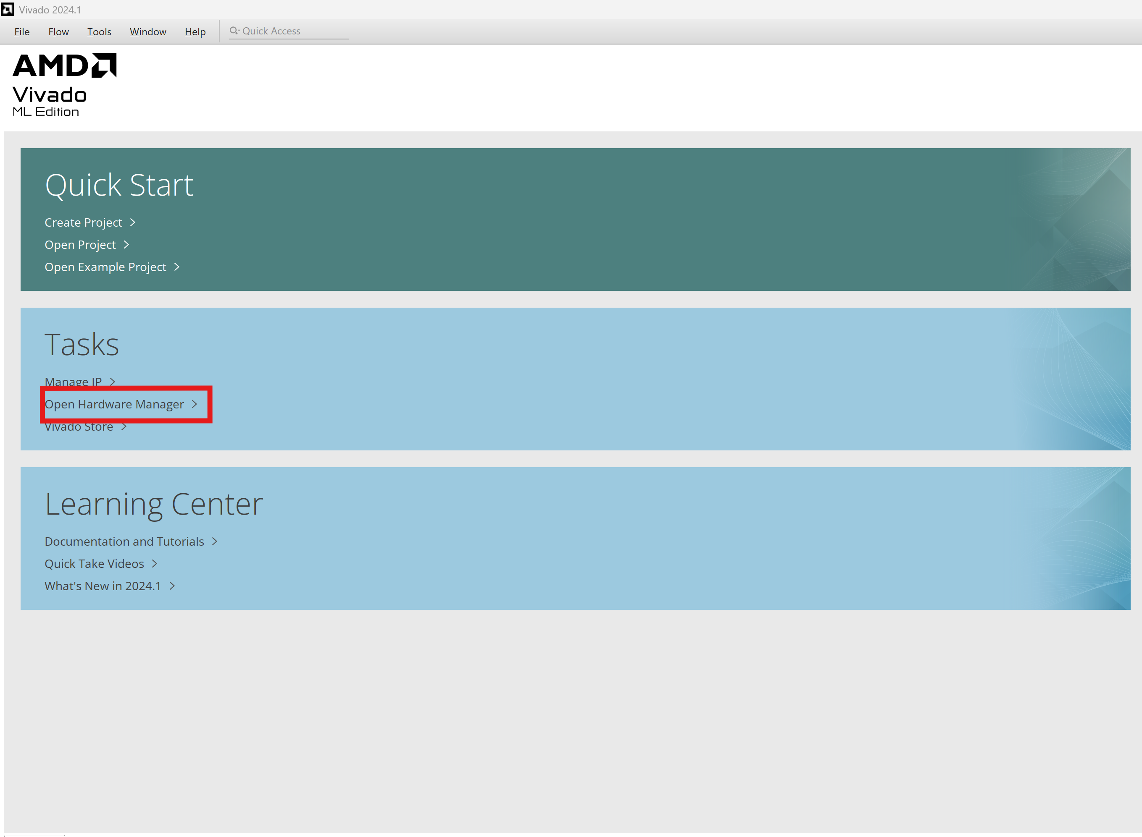

- With USB cable connected to the host computer, Once vivado is open click on “auto connect”
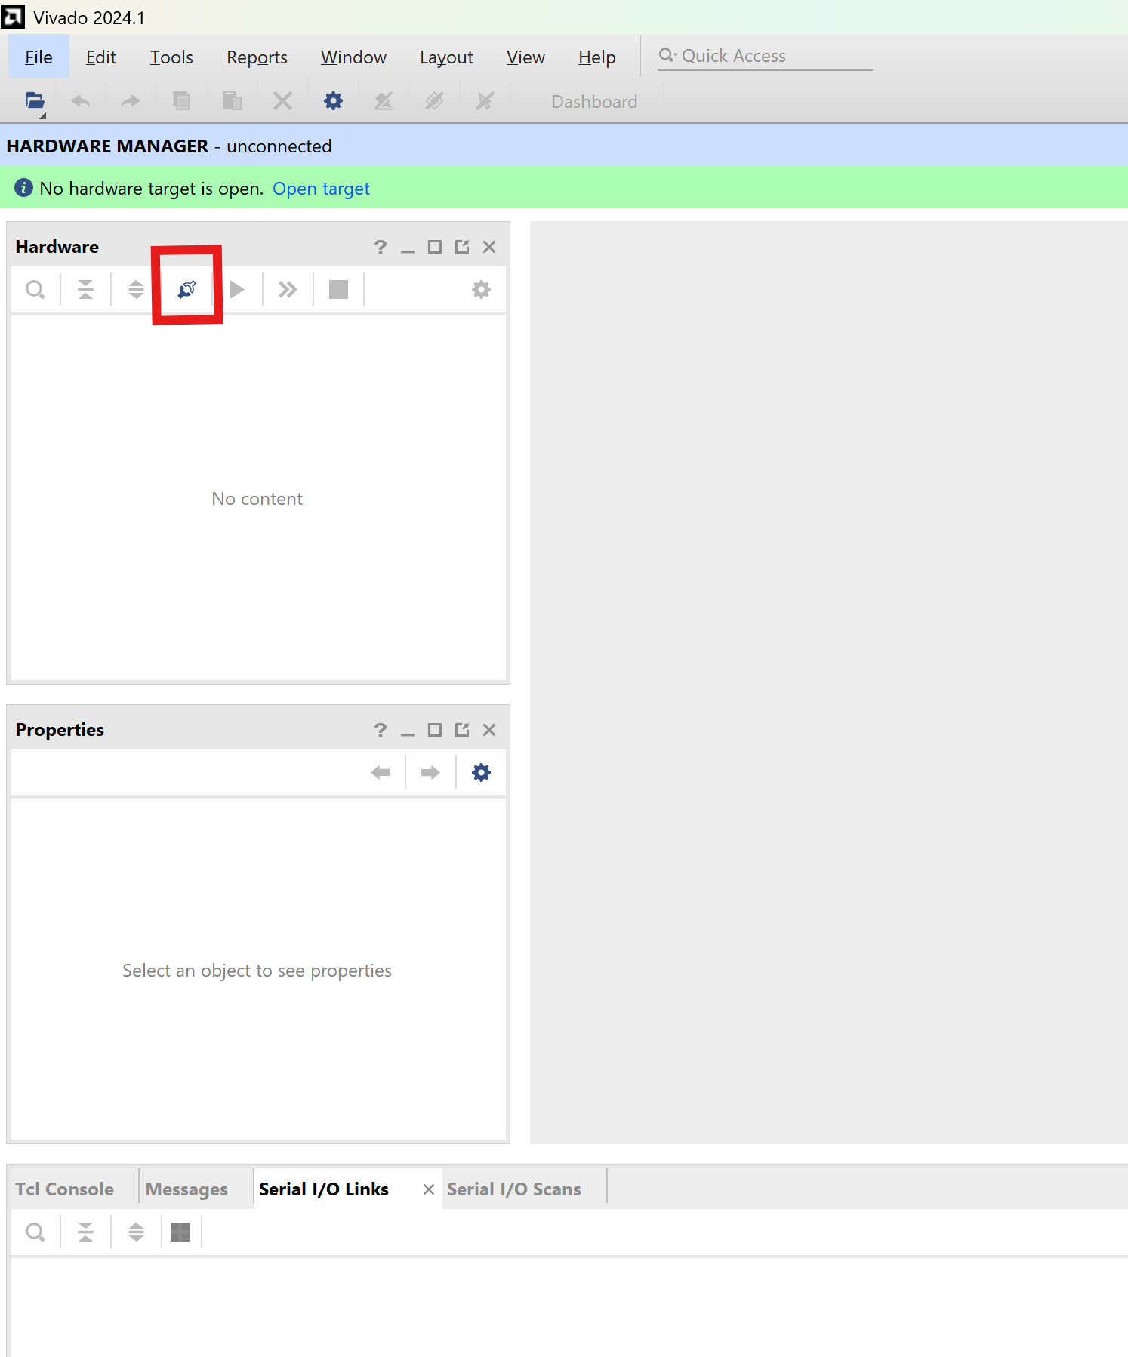

- click on program device
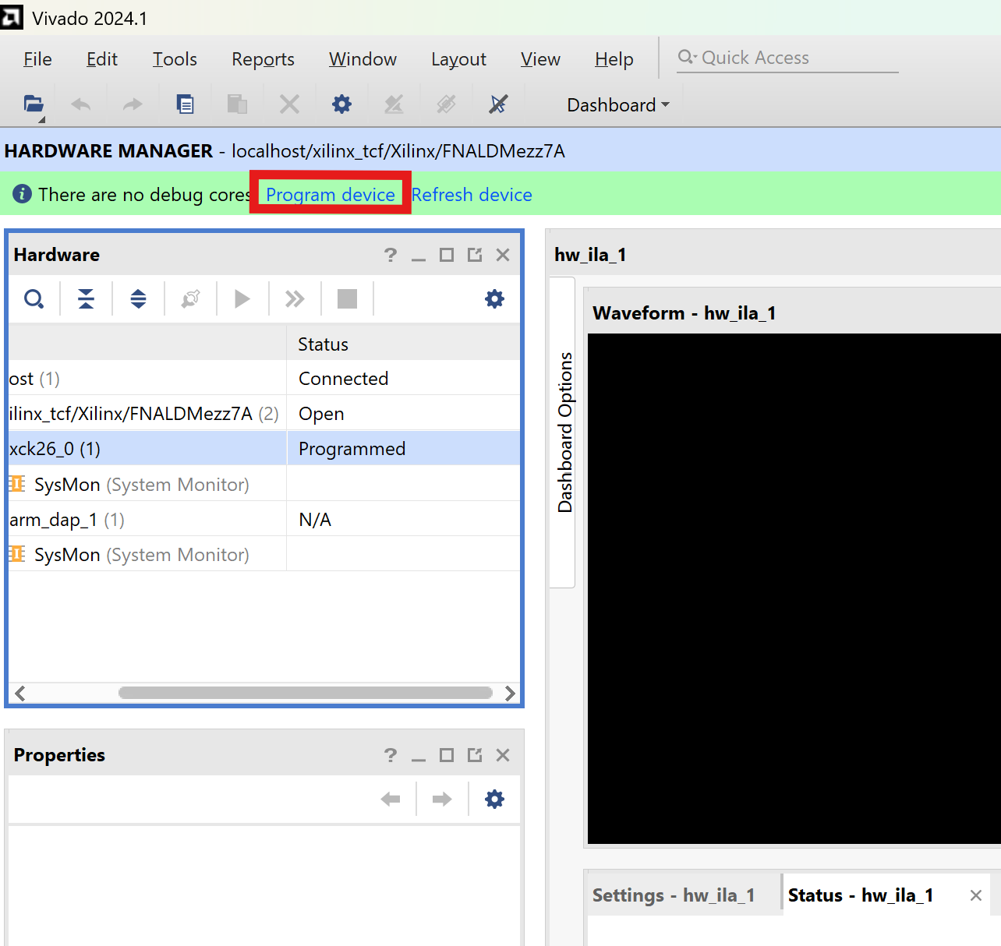
- Select the bitstream file located “ PPDEED - Documents - EYE-SCAN FIRMWARE - All Documents”
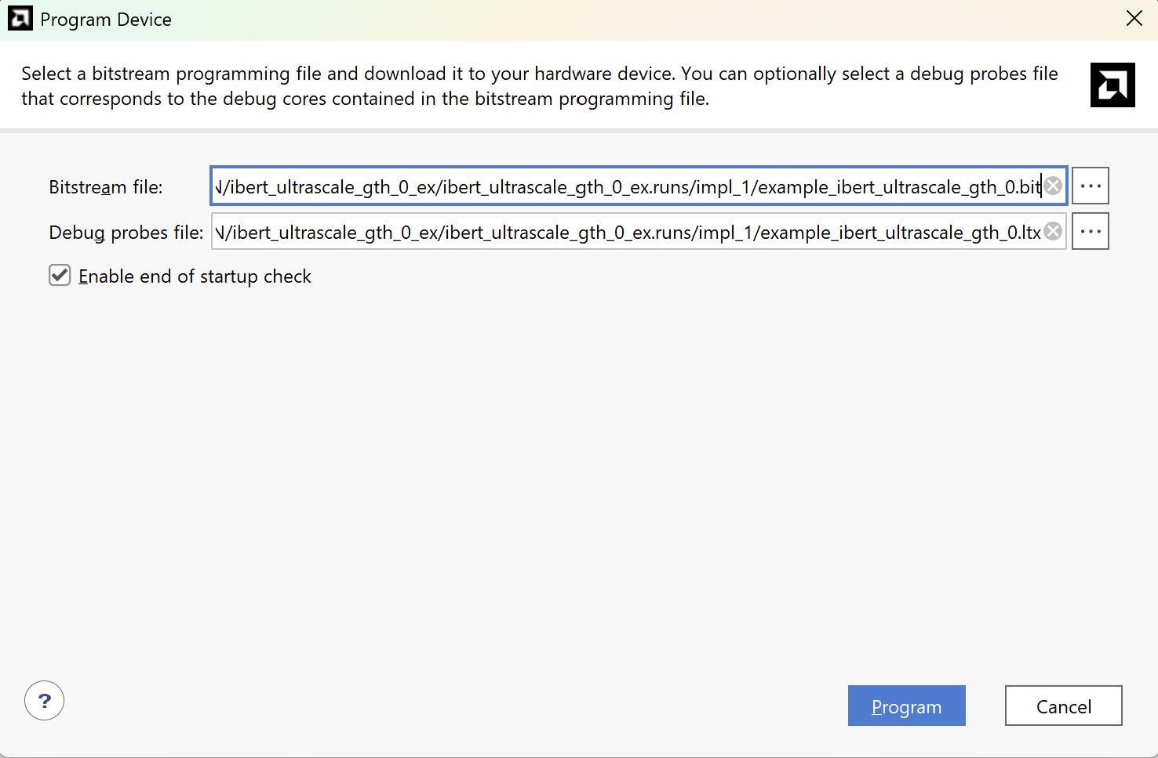
- Once programmed, a window opens that asks for the ltx file

- Once programmed, the vivado window will look as seen bellow. Click on auto detect links
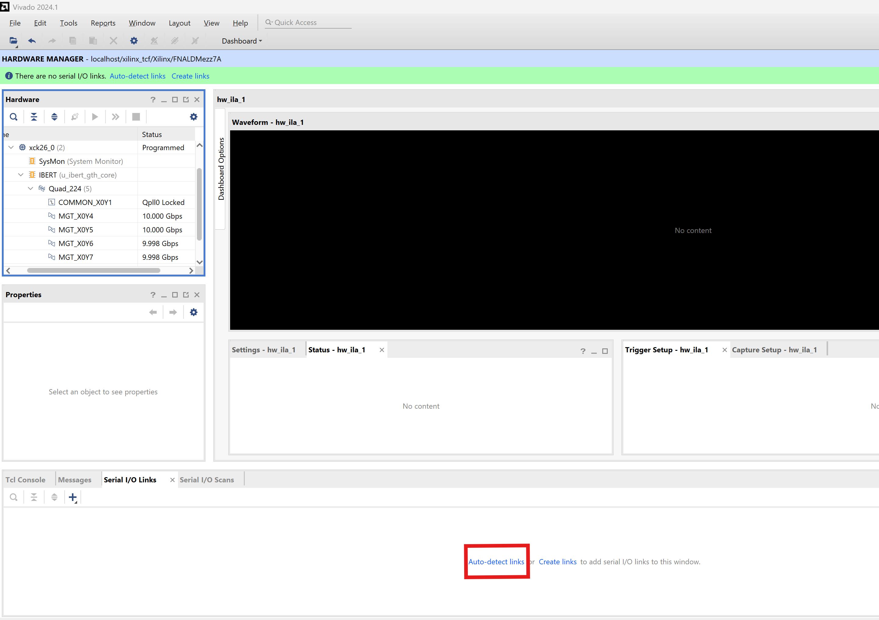
- Once clicked on auto detect links, the window should look as seen bellow. If any of the links shows that the rate is bellow 9.9Gbps or shows that it is red, then the link has issues and must be noted down.
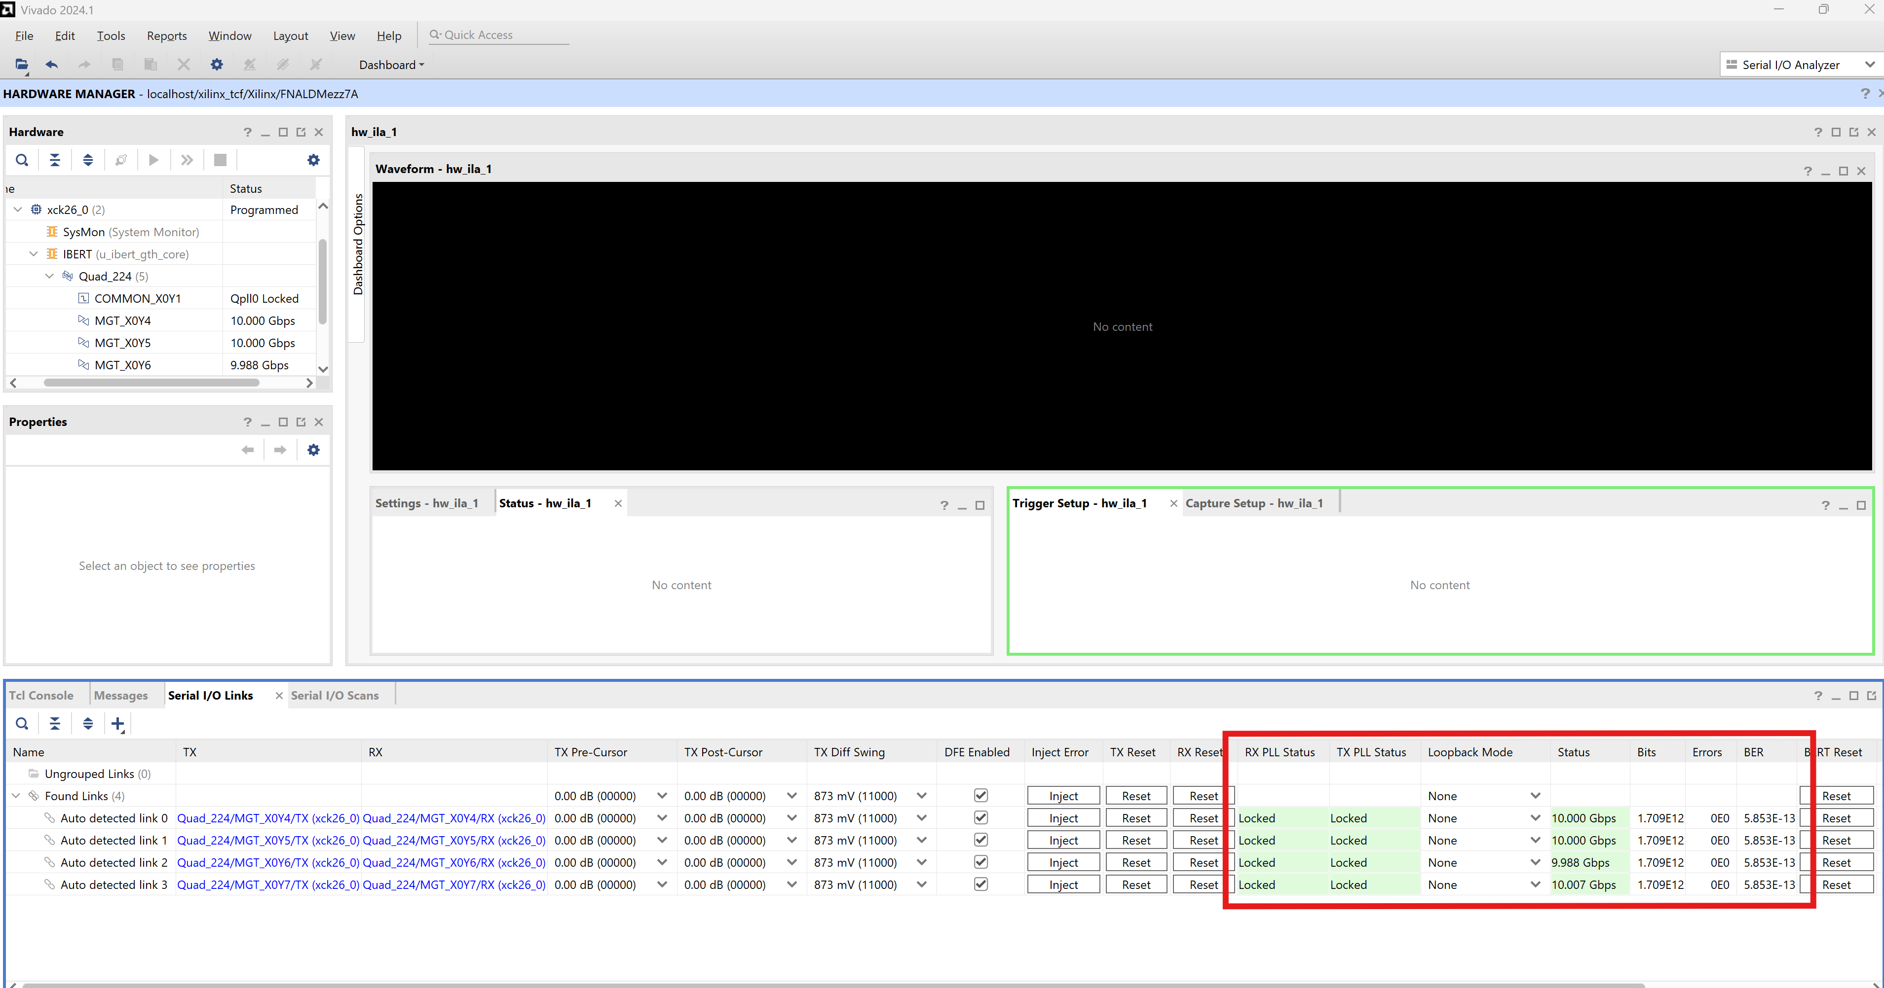

- Now click on serial I/O scans and then create scan to get an eye diagram of the links
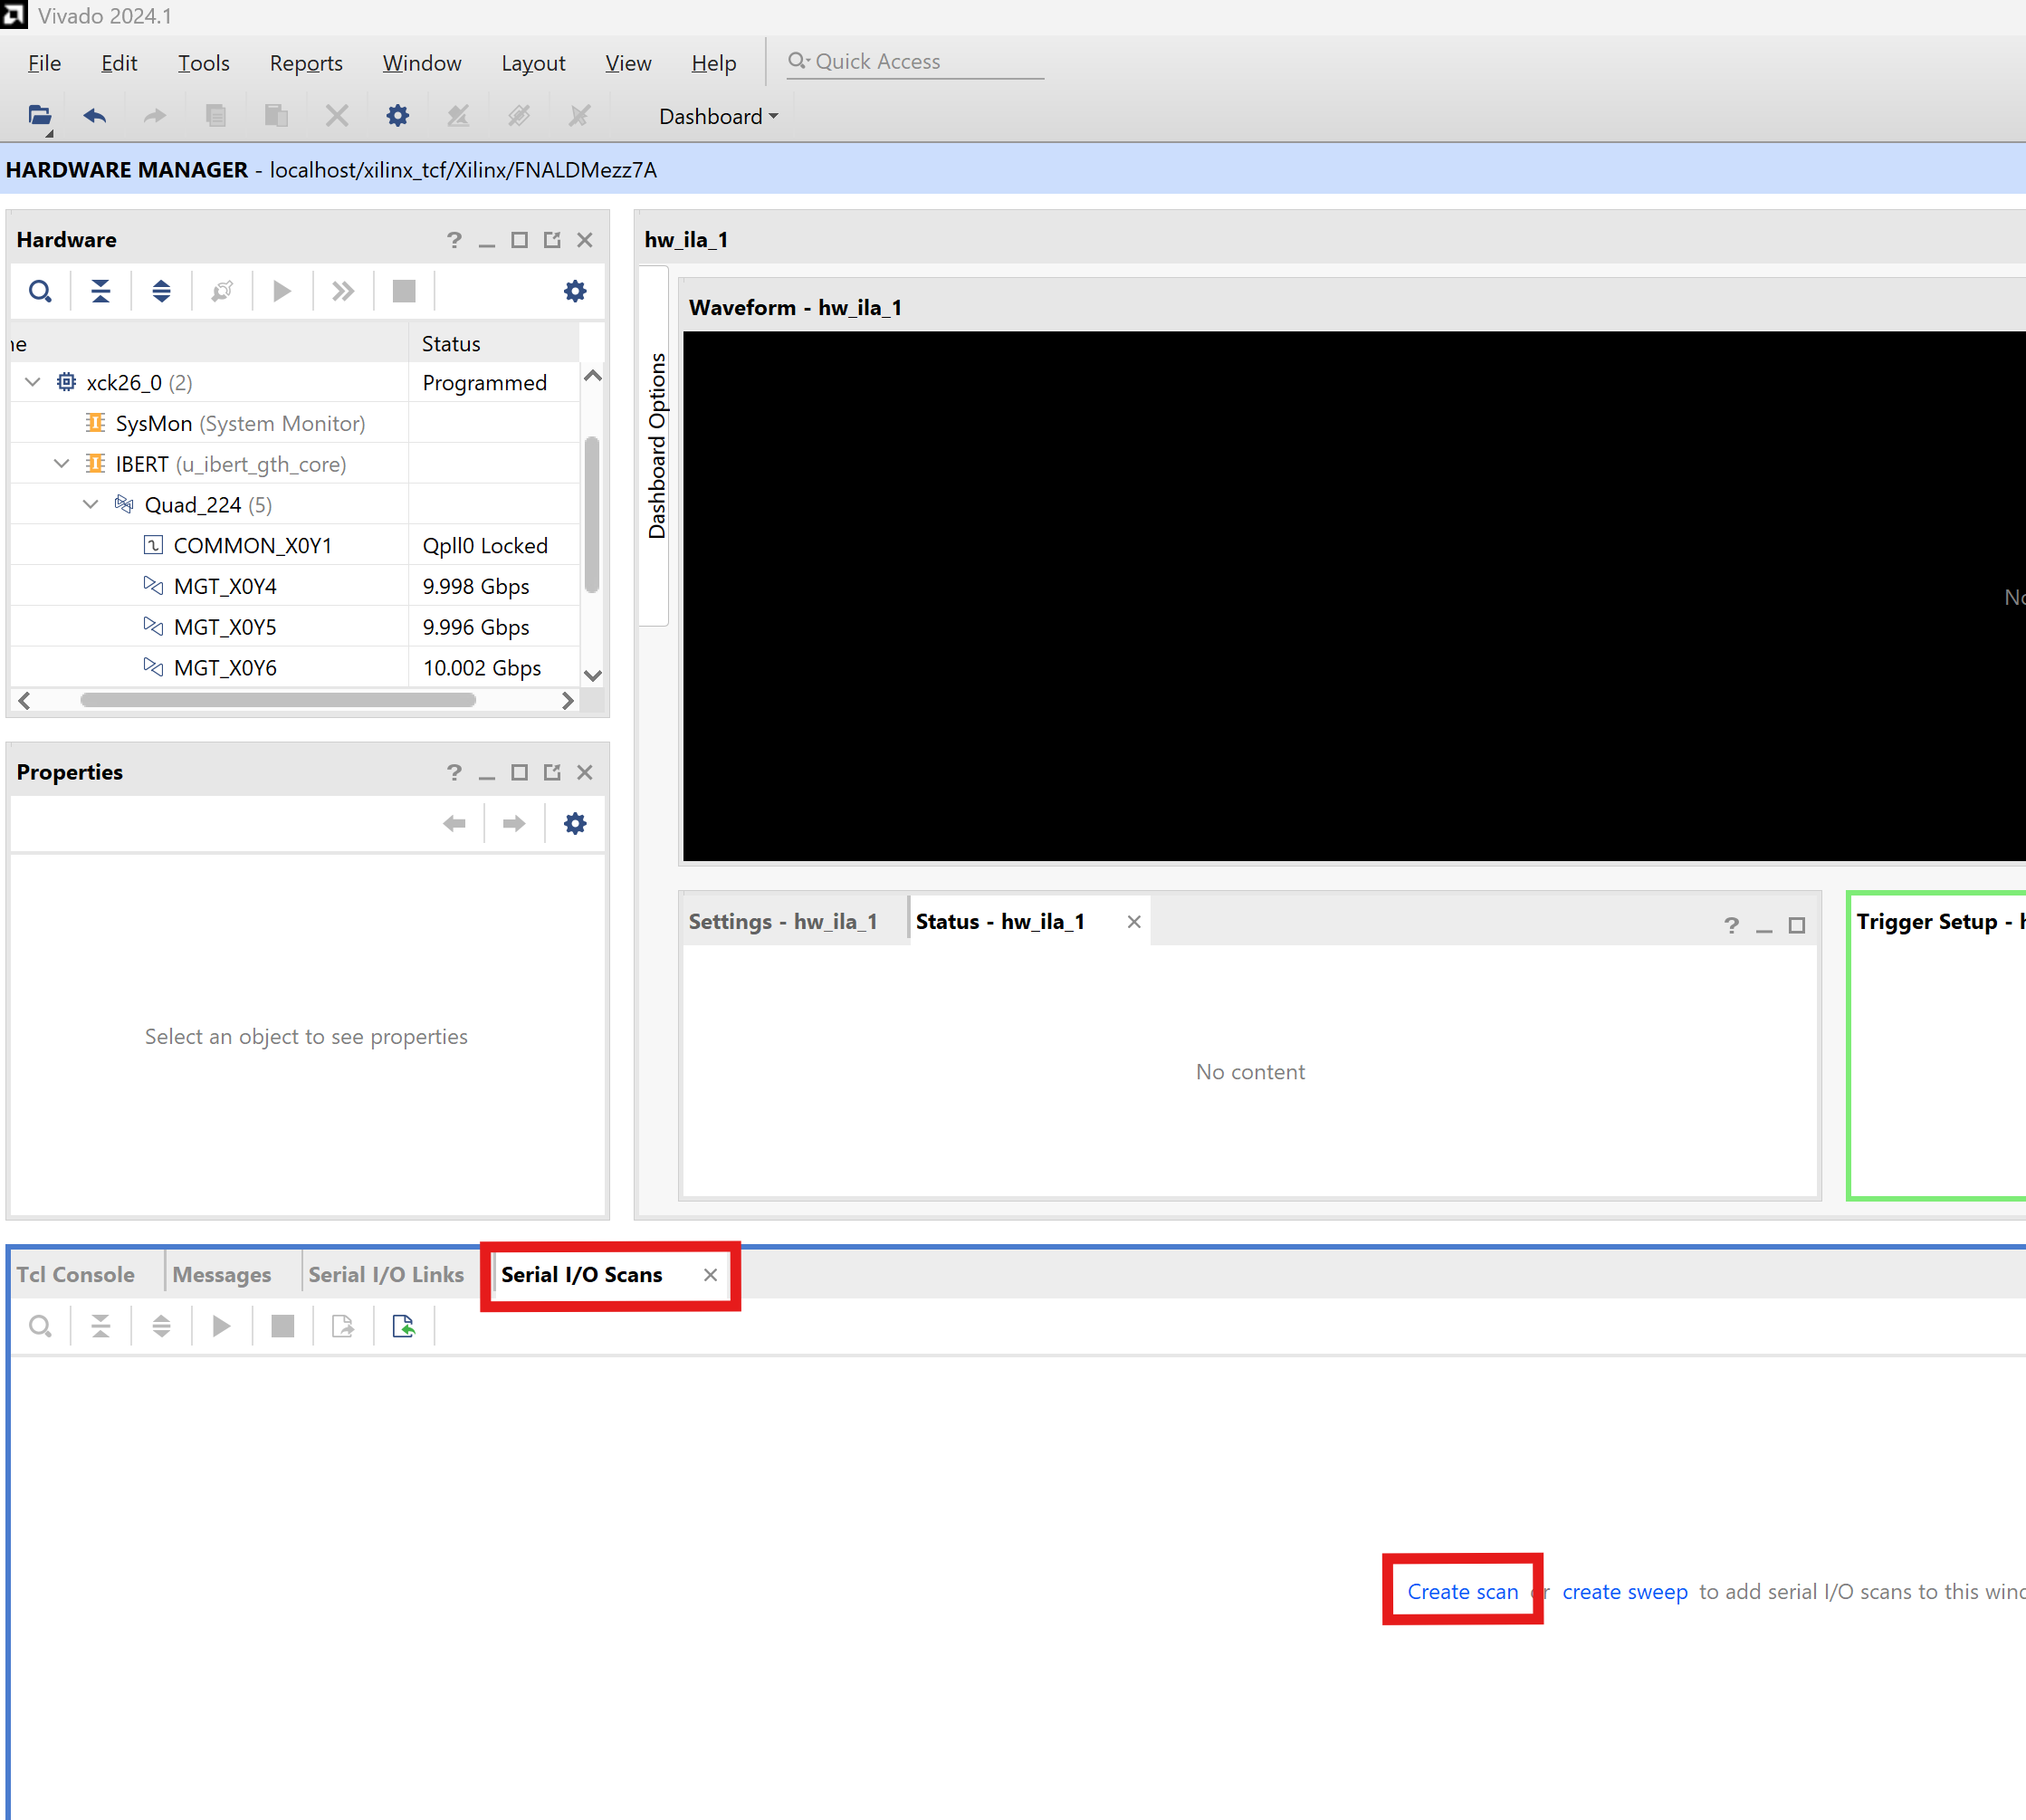
- Use the following setting for the scan
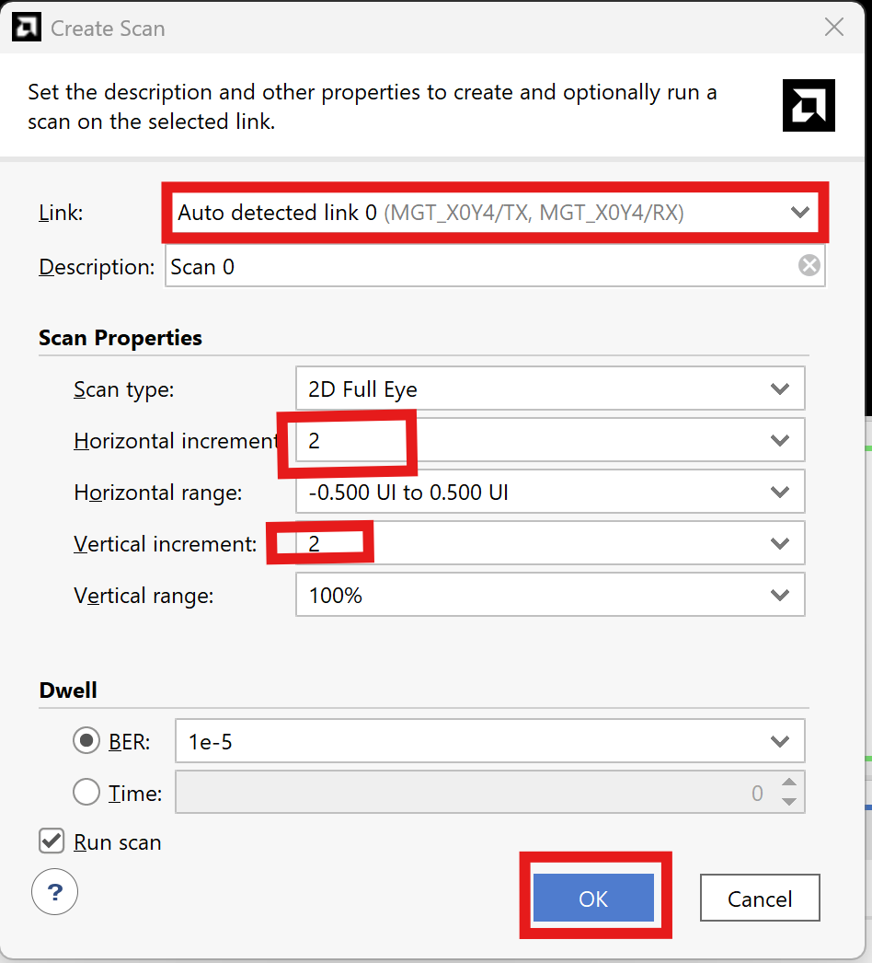

- Once you click ok, the window with an eye diagram will pop up and should look as follow.
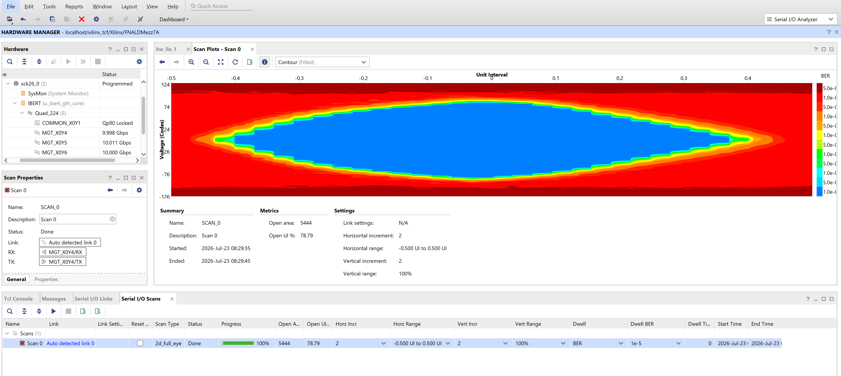
- Now repeat for all 4 detected links

Example of ffts on power rails

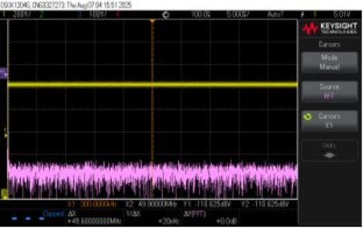
Example of good voltage rail fft

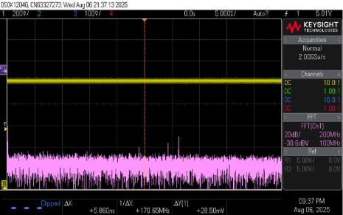
Example of bad voltage rail fft

Example of FFT on open channels
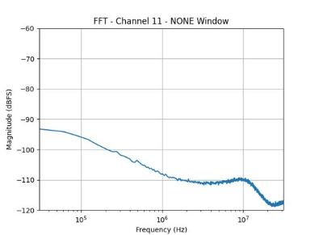
Example good open channel fft
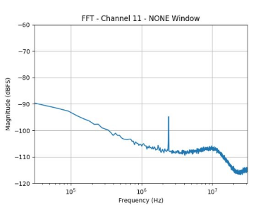
Example of bad open channel fft

Programing SoM and running qc/qa
For programming the SOM follow the instructions from here
https://github.com/DUNE-DAQ/daphne-os/blob/marroyav/reproducible-deployment-station-20261014/scripts/station/README.md.

To run qa, do the following
cd /tmp/daphne-mass-deploy-20260921
B=DAPHNE-00x
IP=192.168.0.20x
bin/run-qa "$B" "$IP"
Results appear under:
/tmp/daphne-mass-deploy-20260921/results/$B/

